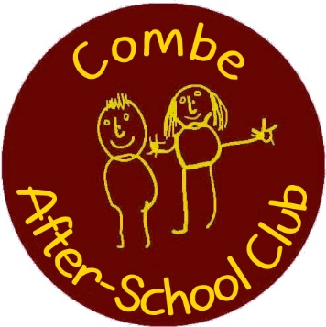
Registered Charity Number: 1022602
Combe After-School Club - Information for Parents
What?
Combe After-School Club is a provision for families who need after-school childcare and are looking for a safe, caring, and happy environment for their children. Run in partnership with Combe Pre-School, it is open term-time from 3-6 pm, Monday to Friday at The Combe Hub, Park Road, Combe. Children will be collected at 3pm by club staff, and then walked over to the club where they will have a light snack and can join in a variety of indoor and outdoor play activities, suitable for all ages from 4 – 11.
How?
All children must be registered with After-School Club to be able to attend sessions. Families can then choose one of the following booking plans:
1/ Regular (£14.20/session) ~ for fixed days per term (£11.70 sibling)
2/ Ad-hoc (£17.00/session) ~ for occasional and last-minute use (£13.50 sibling)
Regular users will be billed at the start of each half term.
Additional sessions may be booked and will be charged on your next bill.
Ad-hoc users will be charged on a ‘pay-as-you-go’ basis, payable by cash or cheque on collection of your child.
Payment is per child per session or part-session.
Childcare vouchers accepted.
For further information, t&c’s, to arrange a visit or to request a registration form:
Tel: 01993 898813
Email: info@combepreschool.onmicrosoft.co.uk
Registration forms can also be downloaded from our website: www.combepreschool.co.uk/combe-after-school-club
Or ask our club staff at school pick-up – they will have registration forms with them and will be happy to answer any questions you may have.

