

Combe Pre-school Newsletter Summer Term 5 2026

Welcome back
It’s a new term, so welcome back to pre-school. We can’t wait to see you all again and to show you some new changes we have put in place for the Summer Term.


Monday 13th April – Start of term 5,
Monday 4th May – Bank Holiday,
Saturday 9th May – Combe Garage Sale,
Friday 22nd May – End of Term 5,
Monday 25th to Friday 29th May – Half Term Holiday,
Monday 1st June – Staff Inset Day,
Tuesday 2nd June – Term 6 starts,

School Dinners
Please remember to order your child school dinners for the term.

Woodland Explorers – Mondays
Our Woodland Explorer sessions continue this term, but unfortunately, we can only take the three and four years olds on these session. This is due to staffing and our high numbers of children in attendance. If you would like to come along and join one of our sessions, then please talk to Lisa. A list of children who will be going to the woods on Monday 13th April was posted on the stories page on Class Dojo at the end of last term, so please take a look.

A New Look!
We have updated our Parents board, which has a fresh new look. Please have a peep, as we will be updating its contents more regularly. We now have a board which displays our more official posters for you to view in the main pre-school room.
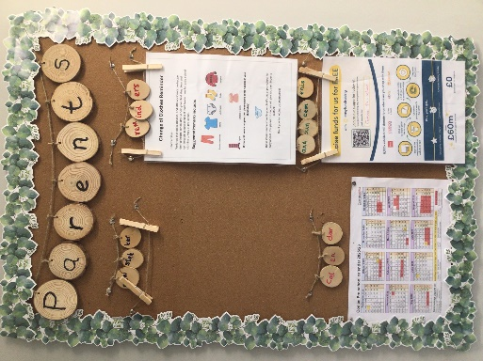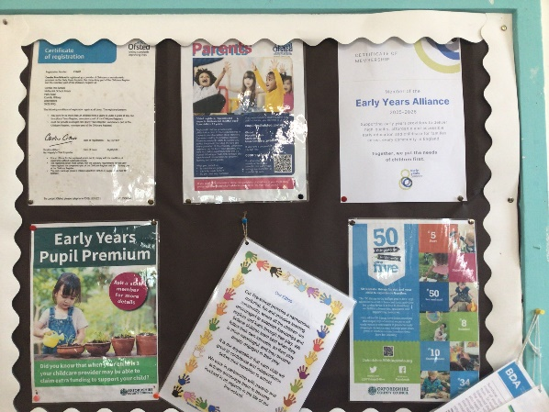

New Flooring
Our quiet room/home corner has had a makeover during the Easter holidays. We now have some lovely new flooring which has helped to make this room look a much more inviting and welcoming space for the children to play and explore.
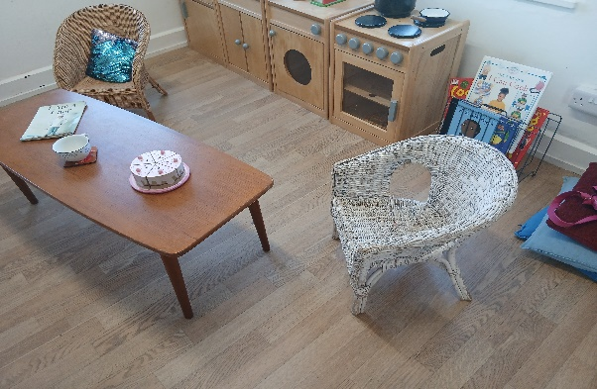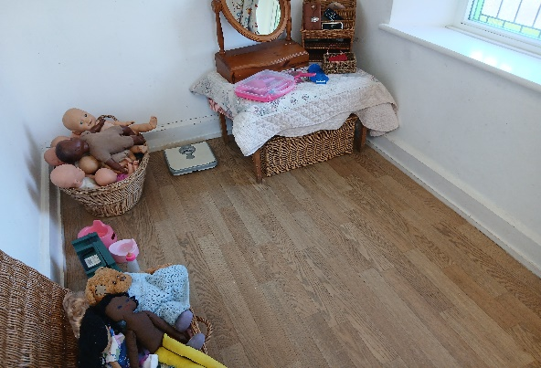

New Wipe Board
We now have a large wipe board where we will be writing a brief outline of what the children have been doing each day. Please take a few minutes to read at pick up times.

Session Request Forms for September 2026
Our session request form for the Autumn term will be handed to you soon. Please make sure you fill in the form and return it to pre-school by the deadline date to secure your child’s place for September 2026. Autumn sessions will be confirmed via email before the end of the summer term.
Your Unwanted items can be our treasure!
We would be grateful if on occasions you could help us by recycling/donating items that you no longer need or want. We are always looking for items to help us add to our resources for the children to explore and play with.
Suggested items include:
Out of date tea bags, rice or pasta, cups and saucers, boxes for junk modelling, clean old paint brushes, unwanted birthday/greeting cards, buttons, egg boxes, old magazines, fabric remnants, carpet and wallpaper samples, and envelopes to use for art and craft activities.
Thank You in advance.
Gardening
We are looking forward to planting flower seeds such as sunflowers, Californian poppies and a few vegetables with the children in the garden this term. We will keep you posted on how our garden area is developing.

Garage Sale
Our fundraising garage sale will be held on Saturday 9th May 2pm to 5pm. Garages will be open around the village to purchase items. There will be refreshments and maps available to buy at the Reading Room, OX29 8NT. Donations of cakes and help on the day will be much appreciated. Please come along and support us.

Easy Fundraising
If you enjoy shopping online, then you can still help us raise funds for pre-school by creating an account and visiting retailers through this site. Companies will donate a percentage of money to our pre-school if you use this site whilst shopping online. You can access the link via our website or by visiting http://www.easyfundraising.org.uk/?v=c.


Website www.comepreschool.co.uk
Our website is regularly updated with news and events, and you can also view our calendar dates for this academic year, so please look from time to time.
Facebook Combe Pre-School | Facebook
Don’t forget to like our Facebook page, where you can keep up to date with events and gain useful information such as activity ideas and information concerning the early years sector.

Thank you for taking the time to read our newsletter.
Andrea, Lisa, Anne-Marie, Kate, Becky, Chloe, Sophie, Harriet and Lois.

