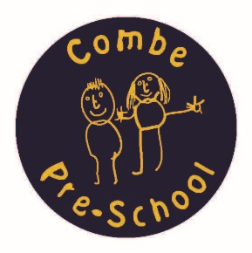

Combe Pre-school Newsletter Autumn Term 2 2016

Welcome
We hope you enjoyed the lovely half term break and that you are all ready to have some festive fun!
Wednesday 2nd November - Term 2 starts @ 9.15am,
Wednesday 23rd November – Saltbox Music session @10.15am,
Thursday 1st December – Parents, Committee & Staff social evening @ 8pm,
Tuesday 13th December – Nativity Play 9.45am for a 10am start,
Friday 16th December – End of term and Christmas Party time TBC,
Wednesday 4th January – Spring Term 3 starts at 9.15am.
New Topic
For our topic this term, we will be discovering all about the weather before we start celebrating Christmas. Here’s what we will learning each week:
Week 1 – 2nd Nov – Sun
Week 2 – 7th Nov – Rain and Clouds
Week 3 – 14th Nov – Rainbows
Week 4 – 21st Nov – Wind
Week 5 – 28th Nov – Mist and Fog /Celebrate Christmas
Week 6 – 5th Dec – Snow/ Celebrate Christmas
Week 7 – 12th Dec - No Planning – Fun Week.

Primary School Admissions
If you have a child born between 1st September 2012 and 31st August 2013 , you can now visit the Primary school admissions page on Oxfordshire County Council's website to apply for a school place for next year.
Deadline for admissions is 15th January 2017.

30 Hours Entitlement Funding.
You may already be aware that the Government is planning on offering 30 hours of nursery education funding for 3 and 4 year olds from September 2017. In order for us plan and prepare for this change we will be placing a survey on your child’s peg to help us determine the need for this funding. Even if your child will be moving on to school, please fill in the survey and return it to pre-school by the given date, so we can use this information to help us shape the future of the childcare we offer at Pre-school.

Session Request form for January 2017
During this term, we will be sending out a session request form to parents in advance of the January term. Our popular Rising Five session will start in January and run until July, so please tick this session if you would like your child to attend. Please remember to return the forms by the given date, to ensure your child has a place.
Boots and Coats
Now that the weather is turning colder, please remember to bring in a pair of boots and a coat so we can take the children outside in all weathers.
Social Evening
On Thursday 1st December @ 8pm, we will be hosting a special Christmas social evening for parents, committee members and staff. You are all welcome to join us for some nibbles and a glass of wine. An invitation will be coming your way very soon.

School Christmas Dinner
The Children will be eating a special Christmas dinner on Wednesday 14th December, instead of the usual menu.

Nativity Play
Our annual Nativity play will take place on Tuesday 13th December, 9.45am for a 10am start. You are welcome to bring along family and friends to watch. Please join us for a mince pie and a cup of tea afterwards.
A letter will appear on your child’s peg containing more information, so please ensure you read this.

Christmas Party
Our Christmas Party will be held on Friday 16th December, which is also the last day of term. The start time will be confirmed closer to the time, but we are hoping that the party will finish around 12pm. Please note that there will be no school dinners, afternoon session or after-school club on this day.
Eco Bags
We will soon be encouraging the children to make some hand prints to place on our annual Eco bags. These make an ideal Christmas gift and memento for family and friends. A letter will be placed on pegs for you to fill in with your order details. Please ensure you enclose payment for your bags with your order form, otherwise we will be unable to give you your bags on their arrival.
Reindeer Food
We will be selling Reindeer food to help glide Santa’s sleigh to your house on Christmas Eve. Bags cost £1 each and will be on sale soon. Please ask a member of staff for more details.

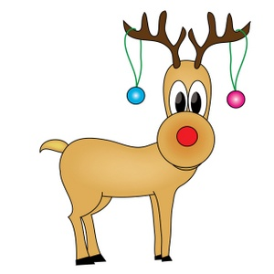

We would like to wish you all a very Merry Christmas and a Happy New Year
Andrea, Vanessa, Fay, Sarah, Anne-Marie & Kate

