Combe Pre-school Newsletter Summer Term 5 2021

We hope you all had an eggcellent Easter and welcome you back to the new term.
New Children
This term we have are excited to have Henry and Esther and their families starting with us and we wish them a warm welcome to Pre-school. We hope they make lots of friends and have great fun playing and learning with us.

Monday 19th April – New term starts,
Monday 19th April – Rising Fives starts,
Monday 3rd May - Bank Holiday no PSC or ASC,
Friday 28th May - Term Ends at 2.30pm or 5.30pm for ASC.
A New Temporary Member of Staff
As our attendance numbers are increasing, we have recruited a new temporary member of staff to join our team. Sophie Lunn is a very experienced Early Years Practitioner with a wealth of experience. She will be working on Monday’s, Wednesday’s and Friday’s, so we hope you will join us by making her feel welcome.
Rising Five’s
Our Rising Five’s session will be running alongside our Monday morning session. This session is only for the children who will be starting school in September 2021. Your child will be able to borrow a book bag so they can practice choosing and reading books with you at home. Please ensure your child’s book bag is returned each week, so they can change their books. We would also like your child to bring in a bag with a suitable PE kit inside. This can be shorts, t-shirt or tracksuit bottoms. Please don’t go to the trouble of buying anything new for your child, any clothing that you have at home will be fine. Please can you put your child’s name or initials in their PE kit, so the staff know which piece of clothing belongs to which child. We want to encourage your children to get changed for themselves to promote their independence skills before moving onto school. As the hub room now has new flooring, please can you also make sure your child has suitable footwear such as trainers, plimsols or some canvas shoes to ensure they don’t slip over on the new floor.
School Dinners
Please ensure you remember to order your child’s school dinners before the start of the new term.
Seeds for School Campaign 2021
We have signed up to join Yarnton Home and Gardens ‘Seeds for school’ campaign. The children will be planting vegetables and flowers from seeds in our extended garden area, and all being well, we hope to enter the three competition categories which are being judged on Thursday 24th June. We are hoping that the children might be able to take some vegetables home to cook and eat. Below is a photo of the free resources that we received as part of the campaign to help get us off to a good start.

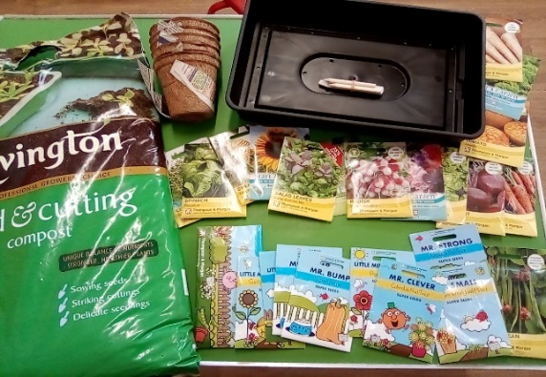

Dental Hygiene
We have recently received some free resources to help us promote the importance of dental health in the prevention of tooth decay in young children. One of our staff has untaken training in this area and will be using these resources with your children over the last two terms of the academic year, to encourage them to have healthy teeth and healthy smiles.
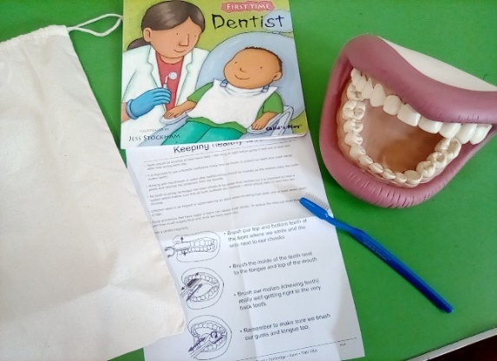

Frogspawn and Tadpoles
The children have really enjoyed observing and helping to care for our frogspawn in our extended garden area. We have been learning all about the lifecycle of frogs from our ‘Frogs’ books and we are hoping that the children will love observing the continuing changes before the frogs arrive.
Butterflies
We have ordered a butterfly garden and caterpillars, so the children can learn about the miracle of Metamorphosise more closely. We hope this will be arriving soon. During the term we are planning on planting some wild flowers near our bug hotel, to encourage bees, butterflies and insects into our wild garden area.
Show and Tell
This term we will be re-starting our ‘Show and Tell’ group time. A message has been sent via Class Dojo about how you can support your child to take part.
Class Dojo
If you have not received an invitation to join Class Dojo, our parent and setting communication system, then please speak to a member of staff.
Easy Fundraising
If you are shopping online, then you can still help us raise funds for pre-school and after-school club by creating an account and visiting retailers through this site. Companies will donate a percentage of money to our pre-school if you use this site whilst shopping online. You can access the link via our website or by visiting http://www.easyfundraising.org.uk/?v=c.

Website
Events, calendar dates and newsletters can be viewed on our website, as we update this regularly.

Face book page
To keep up-to-date with events and news from our Pre-school and After-school club, then please take a look and like our face book page which can be found at https://www.facebook.com/combepreschoolandafterschool. Don’t forget to like us!

Thank You for taking the time to read our newsletter
Best Wishes
From
Andrea, Anne-Marie, Becky, Kate, Lisa, Chloe, Megan and Sophie.

