Combe Pre-school Newsletter Summer Term 6 2021
We hope you have all enjoyed the sunshine during the half term break. The staff would like to say a Big warm welcome to Matilda and her family who joined us at the end of last term and Thomas and William who will be joining us this term. We hope they have a wonderful time playing and learning with us and making lots of new friends.

Monday 7th June – Inset staff training day,
Tuesday 8th June – Term 6 starts at 9am,
Monday 14th June – Rising Five’s starts,
Wednesday 16th June- Fundraising Clothing Collection @ PSC,
Thursday 24th June – Committee, Staff and Parents Social Evening 8pm,
Wednesday 7th July – Rising Five’s visit to Combe Primary school, if restrictions allow,
Wednesday 7th July – Pre-school new starters visit to pre-school,
Thursday 8th July – Pre-school and After-school Club Annual General Meeting 8pm,
Thursday 22nd July – Term ends and end of term party at 12pm.
School Dinners
Please ensure you remember to order your child’s school dinners before the start of the new term.
Sand Pit
Our new sand pit has been extremely popular with all the children. We are hoping to have lots more fun with the sand this term.
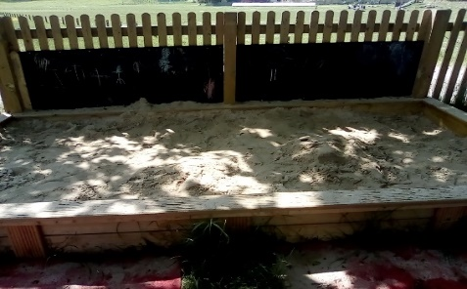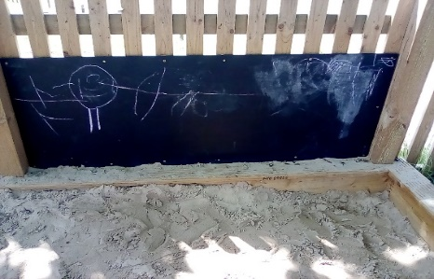
Rising Five’s
Rising Five’s starts again on 14th June, so please remember to bring in a bag with your child’s PE kit to Pre-school on this day.
Healthy Snack times!!
The staff are hoping to encourage even more healthier snack times at pre-school and after-school club, by providing healthier alternatives to jam and honey. We are hoping to introduce light soft cheese, low fat cheese and so on, as an alternative. This is part of our drive and commitment to help encourage oral hygiene, as this is a requirement in the September 2021 new Early Years Foundation Stage.
Sun Cream and Sun Hats
Now the weather has started to get hot and sunny, please don’t forget to apply sun cream to your child before arrival and ensure they have a sun hat to wear outside in the garden. You are welcome to leave a named Bottle of sun cream at pre-school so the staff can re-apply this during the day. Please don’t forget to bring in a water bottle!!
Fruity Tea Bags
If any of you have any out-of-date fruit tea bags, we would be more than happy to take them of your hands. We hope to use them to encourage the children to use these in the mud kitchen and to make special smelly potions.

Pre-school and After-school Club Social Evening
You are invited to join our social evening for all our pre-school and after-school club parents on Thursday 24th June at 8pm. If the government doesn’t lift restrictions on 21st June, the social evening will be held outside (weather permitting) and then groups of 6 people can have a look round inside. This is a good opportunity for you all to come and have a look around the building to see the renovation work that was done last summer to improve our environment. We will be sending more information your way via email and Class Dojo, closer to the time.
New September Starters visit to Pre-school
As our Rising Five’s children will be visiting Combe Primary school on Wednesday 7th July (restrictions allowing), we are planning to ask our new September children and parents in for an introductory visit on this day. The staff are very excited about being able to meet the children and parents on this day. Our Rising Five’s children are welcome to come into pre-school after their school visit, to spend the day playing and learning at pre-school.
Pre-school and After-school Club Annual General Meeting
Our Annual General Meeting will take place on Thursday 8th July at 8pm. All parents are welcome to attend, and if you would like to join our committee to help make decisions about your children’s learning at pre-school, then please come along and join us. Our pre-school and after-school club cannot run without a committee, so please speak to a member of staff if you are interested in joining.
Sport’s Day
We are hoping that the loosening of the covid restrictions will allow us to hold our annual Sport’s Day this year. At this time, we are unsure about a time and date, but if we can go ahead, we will let you know via email and Class Dojo.
Parents Evening
The staff are very keen to hold face-to-face parents’ evenings before the end of term. Again, we will let you know a date, closer to the time.

End of term party
On the last day of term, we are hoping to hold our end of term party. We are unsure whether parents will be able to stay and attend, although we will give you more information over the course of this term.

Easy Fundraising
If you are shopping online, then you can still help us raise funds for pre-school and after-school club by creating an account and visiting retailers through this site. Companies will donate a percentage of money to our pre-school if you use this site whilst shopping online. You can access the link via our website or by visiting http://www.easyfundraising.org.uk/?v=c.

Website
Events, calendar dates and newsletters can be viewed on our website, as we update this regularly.

Face book page
To keep up-to-date with events and news from our Pre-school and After-school club, then please take a look and like our face book page which can be found at https://www.facebook.com/combepreschoolandafterschool. Don’t forget to like us!

Thank You for taking the time to read our newsletter
Best Wishes
From
Andrea, Anne-Marie, Lisa, Becky, Kate, Chloe and Megan.

