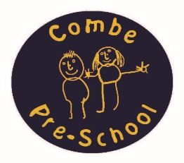

Letters and Sounds – Phase 1 Phonics Workshop

Booking Form

Monday 19th March 2018 6.30-9pm

£10 per person or £30 per setting

Please fill in this from and return it to Andrea Oliver via email to [info@combepreschool.co.uk](mailto:info@combepreschool.co.uk).

Please pay via BACS when booking your place. Sort code 40-52-40 account number 00015622. Please use your settings name as a reference. Thank You.

|  |  |  |
| --- | --- | --- |
| Name | Setting | Contact email or phone number |
|  |  |  |
|  |  |  |
|  |  |  |
|  |  |  |
|  |  |  |

Venue: Combe Pre-school, The Combe Hub, Methodist Church, Park Road, Combe, Witney, Oxon, OX29 8NA