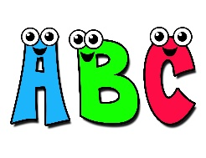
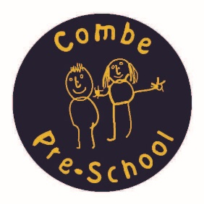

Do you have a systematic phonics programme in your setting?
If not, or if you need a refresher on phonics, then this session is for you!
Letters and Sounds for settings – Phase 1 Phonics workshop
Aims:
- To consider the importance of early language in the process of learning phonics from Nursery to Reception,
- To understand what ‘Phonics’ means,
- To practice pronouncing phonemes (letter sounds),
- To become familiar with the 7 Aspects of Phase 1 Letters and Sounds,
- To explore activities and resources for fun, active and effective early teaching of phonological awareness and phonics,
- To identify ways to develop an environment that is language rich.

Trainer: Sally Purssell (OTSA Teaching School Director)
Date: Monday 19th March 2018
Time: 6:30 to 9pm
Price: £10 per person or £30 per setting
Places: 20 spaces available
Venue: Combe Pre-school, The Combe Hub, Methodist Church, Park Road, Combe, Witney Oxfordshire, OX29 8NA
Refreshments Provided

To book your space, please complete the booking form and return via email to Andrea Oliver to info@combepreschool.co.uk or download from Combe Pre-school’s website on our Training Courses page www.combepreschool.co.uk.

