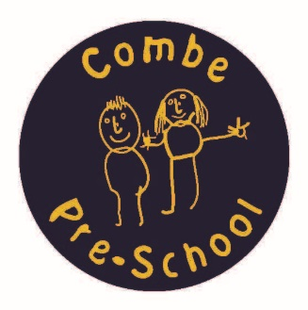
Parental School Dinners Consent From

Childs Name:
Childs date of birth:
Parents Name:
Parents Email:

I hereby give permission for Combe Pre-school to pass on the following information to Combe Primary School, so they can input this information onto Dolce School Grid, to allow myself to book my child in for a school dinners during their attendance at Combe Pre-school.

Parent’s signature:

Date:

